Lesson 1: Integers and Number Lines
GETTING YOURSELF READY
Materials:  Mini whiteboards  Student Handout photocopies |  |  | Your Preparation:  Have student handout ready for the kids. PowerPoint. |  |  | Agenda with times:  Introduction and Purpose: 5 minutes  Key Vocabulary: 3 minutes  Building the Skill: 15 minutes  Structured Practice: 15 minutes  Guided Practice: 10 minutes  Closure: 2 minutes
GETTING YOUR STUDENTS READY
*Do Now:
*NOT APPLICABLE: FIRST DAY* Spend on Introductions
Stand up, say your name, what you want to do as a career, fun fact.
Objective: Today you will be able to understand integers and number lines. |  |  |  | Proving Behavior: By solving integer and number line-related word problems with 80% accuracy.
Purpose: We need to understand integers because we deal with positive and negative numbers when we are working with money. Understanding how to compare, order, and place integers on a number line gives us a sense of what integers are equal to more money and which represent more debt.
Key Vocabulary: (from Glencoe.com)
SAY: The following definitions
SEE: Examples of each on PowerPoint (like those provided on the handout)
DO: Each person must pick one of the terms and either draw a representation of it or another analogy on the whiteboard. Preferably not one already provided by me.

Whole numbers: counting numbers (your “regular numbers” you can count on your fingers) and zero. Wh0le numbers!
My favorite numbers “Ho”
Opposites: numbers same distance from zero, or same “value” (regardless of sign)
Integers: whole numbers and opposites. Just “chunks,” no bits and pieces (like 3.5)
Positive integer is:
- number greater than 0
- hot temperature
- pile of sand
Zero is
- non-negative, non-positive
- just 0 degrees (“just warm”)
- just flat ground
Negative integer is
- number less than 0
- cold temperature
- a hole in the ground
Opposites: numbers same distance from zero, or same “value” (regardless of sign)
Absolute value: distance of number from zero (or basically number without its sign)
They can check out the provided definitions on the handout
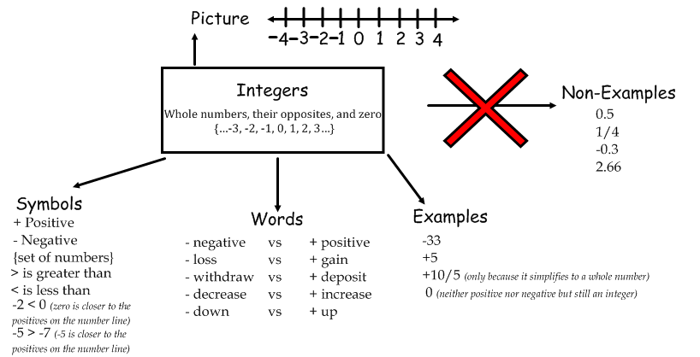

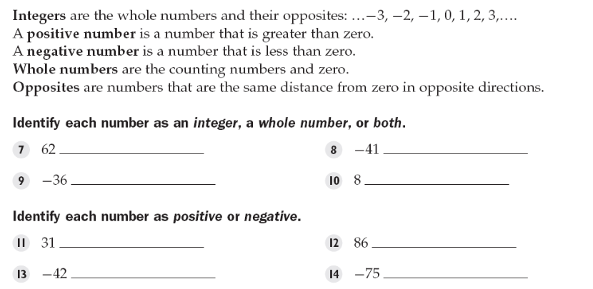
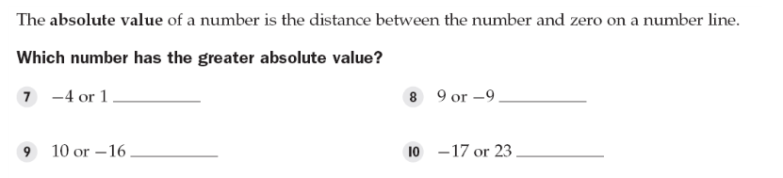

BUILDING THE SKILL
Integers and Number Lines | Say/See: Think aloud number 1 of plotting the integers on the number line by making a point on the number line above each number. Show the students how number lines allow us to easily see the order of integers from least to greatest because we can look from the left to the right on the number line and list them in order of smallest to largest..  Another analogy: the hole. Make the number line vertical. 0 is ground level. Numbers above zero are positive and represent height of a sand pile. Numbers below zero and negative and represent depth of the hole.  Another analogy: temperature. Gets hotter as you go the right (higher temperature). Colder as you go to the left (colder temperature). E.g. “-40 degrees” is obviously cold. IMPORTANT FOR THE NEXT LESSON.  Another analogy: Think aloud writing the integers in number 5 from least to greatest. Explain that we could draw a number line and plot each integer in order to list them, but instead, students could think about money. Negative numbers mean debt. If they owe $21, then they have less money than if they owe $15 because they are farther away from reaching zero when they owe no money. Therefore, negative numbers get larger the closer they get to zero or to the positives.  Do: Have the students complete 2-4 independently and show you their work. Whiteboard drill 6-8 (raise their whiteboards with the answers). Then, have them complete 9-16 in partners. I will walk around.  Say/See: Think aloud how to name integers when they are listed as a numerical expression.  Do: Have the students write the following on the top of their whiteboards: -4 – 5 + 9 – (-2) – 2 + 5 – 5 + 2 and then circle each integer with the sign to the left of it. Have them chorally read the list of integers in the expression.  Say/See: Think aloud how to find the integers in the word problem. Do not solve the problem.  Do: First, have the students shout out key words that signify “positive” and “negative” integers. Write them on the board. Then, have the students identify the integers in the second word problem and then chorally yell out the integers. Do not have them solve the problem.
PRACTICING THE SKILL
*Structured Practice
Time: 5 minutes  Materials: index cards, bag  * If students do not need extra practice in this area, skip this Structured Practice Activity. |  | Activity from Glencoe.com
Time: 5 minutes
Materials: index cards, bag
* If students do not need extra practice in this area, skip this Structured Practice Activity
Time: 5 minutes  Materials: Word Problems  Group Size: Pairs  Materials: Mini Whiteboards |  | There are five problems on the Structured Practice Worksheet. Have students work in pairs and hold up their boards for each problem. The final problem will take some time. Each pair will share their problem and the entire class will do the problem on whiteboards.
*Guided Practice (the proving behavior of the objective monitored by teacher)
Assignment: Guided Practice Handout. Have the students complete the remainder of the word problems. Make sure they show their visualization for each problem. |  |  |  |  | Criteria for Mastery: 80% of the remaining problems.
Explain Homework: Independent Practice Handouts. Have students show their work and complete the problems. Also, bring a chef’s hat or apron or kitchen-related apparel tomorrow!
*Closure: On an index card, create one word problem that you feel would represent this lesson. On the back of the index card, solve the problem and make sure you show your visualization.

